|  |  |  |  |  |
| --- | --- | --- | --- | --- |
|  | | Mathematics Essentials 2019  Test 2 Unit 2  Task Weighting: 9%  Time and Motion | | |
| Student Name: |  | |  |  |

Time Allowed: 20 Minutes Total Marks: 26

**PART A Calculators are NOT allowed in this section.**

**Question 1**  **(4 marks - 1, 1, 1, 1)**

1. Convert the following times to those in brackets:

i) 0045 h (12 hr) ________________ ii) 2331 h (12 hr) ________________

1. Convert 2.75 hours to minutes, 2.75h = ___________________minutes
2. Calculate the elapsed time from 2:45 pm until 8:20 am the following day.
3. What is the time 2 $\frac{3}{4}$ hrs before midday?

**Question 2** **(3 marks – 1, 2)**

1. Vanessa’s flight lands in Singapore at 0840h. Her next flight leaves Singapore at 1820h. How long does Vanessa have have to wait in the airport before she departs Singapore?

1. Peter wants to go for a bike ride which takes 52 minutes. He also wants to watch his favourite television show which starts at 7:35 p.m. What is the latest time that he can leave for his bike ride and be back in time to watch television?

**Question 3 (2 marks – 1,1)**

Tom and Jerry competed against each other in a race. Tom completed the race in 0.75 hours while Jerry took 50 minutes.

1. Who won the race?
2. Explain your answer

**Question 4 (5 marks - 1, 1, 1, 2)**

1. Convert this graphical scale into a ratio scale

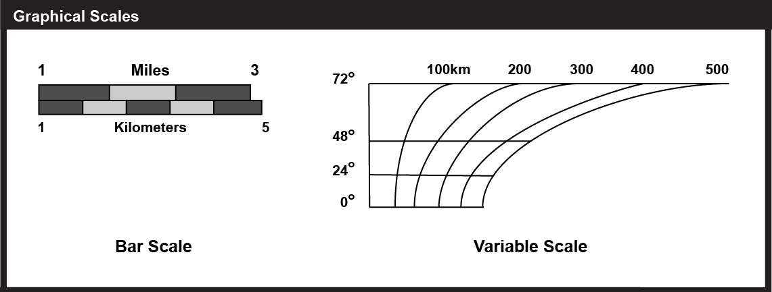

0

1. 1 cm to 200 m can be written as 1: _________________
2. A map scale of 1 : 3000 means 1 cm on the map represents ___________ metres in real life
3. If the length of a room was 560cm and the floor plan scale was 1:80, how long

would the line be drawn on the plan?

**Question 5 (4 marks – 2, 2)**

Match graph’s **a** to **d** with the descriptions **A** to **C** below. For the graph that does not have a description write your own.



1. Brett stayed the night at his friend’s house then he drove straight home in the morning.
2. On his way to TAFE, Terry stopped at his work to pick up some tools. After he finished TAFE, he returned the tools to his work before he went home.
3. After breakfast, Meshal drove to her friend’s house. She stayed at her friends house for 2 hours and then she drove home.
4. _________________________________________________________________________

_________________________________________________________________________

_________________________________________________________________________

**Question 6** (**8 Marks – 1, 1, 2, 2, 1, 1)**

The following graph shows the distance of a cyclist from his home

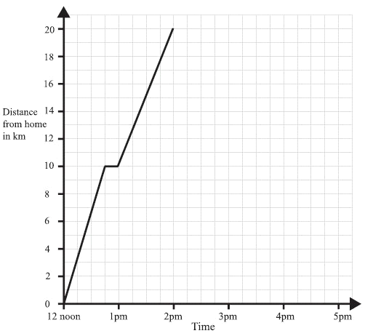

a) For how long did he rest initially (for the first time)?

b) How far away from home was he at 1.30 pm?

1. What may have happened when he was 10 km from home before 1 pm? Explain.

d) What was his ‘average’ speed for the entire bike ride?

1. i) How can you tell from the graph when the cyclist was travelling most quickly?

ii) Between what times did this occur?

End of Part A

 Mathematics Essentials 2019

Test 3 Unit 2

Task Weighting: 9%

|  |
| --- |
| Student Name: _________________________________________________ |

Time allowed: 30 minutes Total marks: 23

**PART B Calculators and notes are allowed in this section.**

***Show all working where appropriate to maximise marks.***

**Question 7 (7 marks – 5, 2)**

Three different families drove their cars from one town to another as they enjoyed their holidays. They used a map of the south-west region of Western Australia which has a scale of 1:750 000. Pairs of towns are listed in the table together with some actual distances. The weather conditions required them to travel at different speeds.

|  |  |  |  |  |  |
| --- | --- | --- | --- | --- | --- |
| FAMILY  NAME | SOUTH-WEST TOWNS | DISTANCE  (km) | MAP DISTANCE (cm) | AVERAGE SPEED( km/h) | TIME TO TRAVEL ( h) |
| Smith | Bunbury to Augusta | 142 | 19 | 95 |  |
| Brown | Walpole to Busselton | 238 |  |  | 2 |
| Jackson | Donnybrook to Bridgetown |  | 7.5 |  | 0.6 |

1. Use your knowledge of distance, speed, time and scale to complete the table.
2. One of the families broke a traffic rule. Which family broke the law? Explain your answer.

**Question 8**  **(6 Marks - 1, 1, 1, 3)**

The actual straight line distance between Merredin and Southern Cross is 106km.

Using the map below calculate the following:

a) What actual distance would be represented by 1 mm on the map?

b) What actual distance would be represented by 1 cm on the map? Round your answer to the nearest km

c) Write the scale of the map based on your answer to part b).

d) Use your scale to calculate the distance between Moora and Koorda. Explain if your answer is reasonable.

**Question 9 (5 marks – 3, 2)**

|  |
| --- |
| FOR SALE BY AUCTION  DEVELOPMENTAL PROPERTY  *Located in a soon to be developed city centre*  Land area:  8000m2  50m street frontage |

The advertisement on the right is taken from a real

estate agent’s for sale listings.

1. Using a scale of 1:2000, draw a diagram of the property for sale.
2. If the property can be broken into individual blocks measuring 10m x 40m, show, using your diagram, the number of individual blocks that can be created.

The number of blocks is : _____________

**Question 10 (5 marks)**

Sheila works for Ace Taxis.

Ace Taxis uses three taxis: Alpha, Beta and Charlie

Sheila takes bookings from customers who want taxis.

|  |  |  |  |  |  |  |
| --- | --- | --- | --- | --- | --- | --- |
| Booking Sheet for Tuesday | | | | | | |
| Customer | From | To | Pick up Time | Drop off time | Journey time  (in minutes) | Taxi |
| School run | Grindley Street | Merton School | 8:15 | 9:00 | 45 | Alpha |
| School run | Marsh  Bank | Merton School | 8:15 | 9:00 | 45 | Charlie |
| Miss Egan | Boston Road | Station | 7:00 | 7:15 | 15 | Alpha |
| Ms Green | Bank Street | Clinic | 10:05 | 10:30 | 25 | Beta |
| Mrs Adams | Copley Estate | Shopping Centre | 9:25 |  | 20 |  |
| Miss Crispi | Shopping Centre | Green Lane Estate | 10:10 |  | 25 |  |
| Mr Smith | Copley Estate | Station | 7:20 |  | 25 |  |
| Mr Micel | Rose Avenue | Shopping Centre | 9:40 |  | 25 |  |

Shelia makes a booking schedule to show which taxi will be sent to each customer.

She allows 15 minutes between dropping off one customer and picking up the next.

Shelia has written four bookings on the booking schedule.

Complete the booking sheet and the booking schedule to show which taxi will be sent to each customer.

|  |  |  |  |  |
| --- | --- | --- | --- | --- |
| Booking Schedule | | | | |
| **Taxis** | **7:00** | **8:00** | **9:00** | **10:00** |
| Alpha | Miss Egan  (7:00 – 7:15) | School run  (8:15 – 9:00) |  |  |
| Beta |  |  |  | Ms Green  (10:05 – 10:30) |
| Charlie |  | School run  (8:15 – 9:00) |  |  |

End of Part B